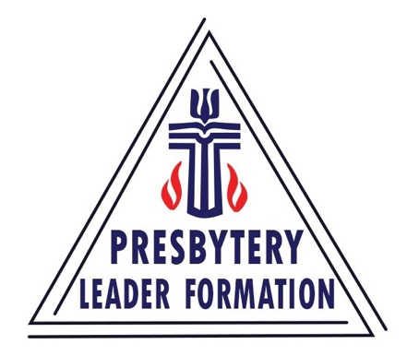
Presbytery Leader Formation
Beginning in Mid Council Ministry PC(USA)

Mid Council leadership is an exciting opportunity for those who serve the church!
It can be creative and fulfilling, daunting and lonely all at once.

Whatever the title — executive, general or lead presbyter — support and encouragement as one enters these kinds of roles can make a huge difference to the leaders and those whom they serve.

The Presbytery Leader Formation (PLF) Program is a three-year opportunity designed to provide education, nurture and collegiality during this key time.

A Brief History

The Association of Executive Presbyters began in the 1980s. From their beginning, the Association demonstrated a commitment to training newly-called leaders. In 2005, the Association appointed a task force to expand on the training that it offered for new presbytery leaders.

In 2008, after several years of planning and experimentation, the Association
approved “Presbytery Leader Formation: A Plan for Formation, Development and Support.” A Coordinating Team was created to oversee the program. From its inception, it relied upon the financial support of presbyteries, synods, the Office of General Assembly and the Association of Mid Council Leaders.

What’s inside the
Presbytery Leader Formation program
A 90-Day Companion
A seasoned leader paired with a new leader who pray for one another and hold regular phone con- versations over a three-month period, as the new leader becomes oriented to the world of mid council leadership!

Coaching
Executive/general presbyters are paired with a new mid council leader soon after arriving in the presbytery. The program provides 36 monthly one
-hour coaching sessions.

Residency
Three five-day residencies over the three-year period are held for fellowship, learning and robust worship. Topics vary, including things like change and systems theory, church conflict, the role of the leader and response to misconduct. Topics are reviewed and updated yearly for relevancy.

Costs
A portion of the costs for the three years (including scholarships) are ordinarily shared among several entities, including:

AMCL (Association of Mid Council Leaders)
$5,000 annually toward administration

OGA (Office of the General Assembly)
plans and covers the cost of the orientation for new executives, associate executives and stated clerks
Participants’ Presbyteries
$1,300 toward each of the three residency gatherings, plus the cost of travel to the orientation and three residencies
Participants’ Synods
$1,500 for each of three years of coaching
Gifts and Donations
from generous individuals and entities help make the program sustainable.

